For starters, he’s a legendary recruiter for GSAE, winning our Benson Skelton Award for membership recruitment 14 times since its introduction in 1969. It was renamed the Skelton-Massey Award in 2011. Those of you who are regulars at this luncheon have probably marveled at his uncanny ability to deliver a flawless, riveting, and very detailed introduction of the luncheon speaker from memory.
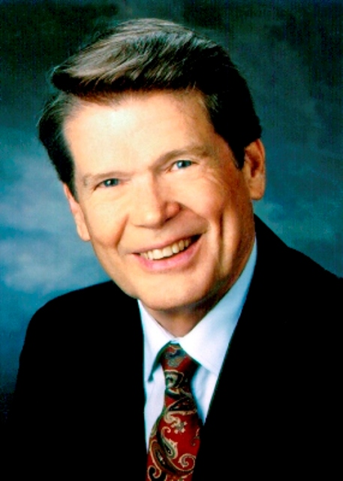
Abit joined the Georgia Poultry Federation in 1960 as its executive director and was named its president emeritus a few years ago.

He has received a host of honors during his distinguished career of service to our state and to the nonprofit community. For starters, he is a recipient of GSAE’s highest honor, the Clifford M. Clark Award. He received the Key Award from ASAE, which is that organization’s highest honor. As a GSAE volunteer, Abit successfully lobbied for the Georgia law that provides that officers and directors of nonprofits are exempt from civil liability as long as we are acting in good faith. As chair of ASAE, he led a successful effort to secure legislation providing tax exemption for trade show income for nonprofit associations. He later worked with ASAE on the effort to solidify our tax exemption for investment income. Abit has saved most of our organizations a LOT of money over many, many years.
Abit has also made—and been recognized for—tremendous contributions outside of the world of association management. Abit has received awards for outstanding or distinguished service from the National Association of Vocational Home Economics Teachers, the UGA Blue Key Honor Society, the UGA Ag Alumni Association, the UGA National Alumni Association, US Poultry & Egg Association, and the Agricultural Economics Association of Georgia. (That last award was created especially for him.) Also in 2009, he received a Presidential Citation from Georgia Tech – for remarkable service to the state and the university. This was only the seventh such citation ever presented by Tech, and the first to a Georgia Bulldog.
Abit has given time, talent, and treasure to so many organizations, serving on the board of directors of the UGA Ag Alumni Association, the UGA Alumni Association, the Georgia Research Foundation, the Georgia Council on Economic Education and the UGA Real Estate Foundation. He was the first man elected to serve on the board of Georgia Women of Achievement. As recently as the last two years, Abit received more significant honors. In February 2021, he was inducted into the Poultry Hall of Fame and in August 2021, he was awarded the 4-H Green Jacket. Most recently, Northeast Georgia Council, BSA recognized him as a 2022 Silver Beaver Recipient. Abit is a deacon and trustee of the Gainesville First Baptist Church.
Abit lives in Gainesville, The Chicken Capitol of the World, with his lovely wife Kayanne, who he successfully courted during her reign as Miss Georgia. They’ve been blessed with two children and four grandchildren. The legacy that Abit and Kayanne have built in the Massey family was recognized when they were named the Alumni Family of the Year by the UGA Alumni Association. Abit gave the final summer commencement address at the University of Georgia in 2014 and is featured in UGA’s oral history project.

Oh, and the address of the Georgia Poultry Laboratory just north of Gainesville? It’s 3235 Abit Massey Way.

